ECE 243 project
Group member: Weiqing Zhang, Yunhuan Zou
Project name: tank’s war

Block diagram
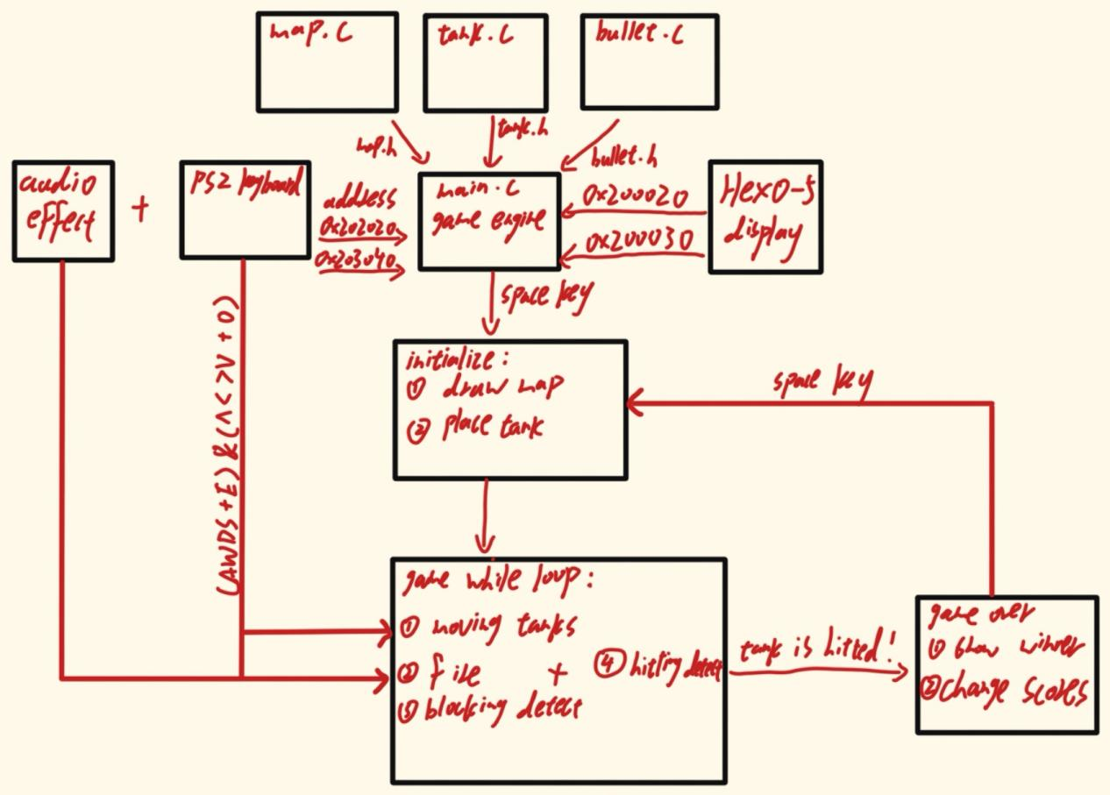

Project description
This project is a two-player battle game, where Player 1 (initialized at left side of the map) uses AWDS keys to move and Q to fire, while Player 2 (initialized at right side of the map) uses up, right, down, left direction keys to move and M to fire. Randomly generated obstacles appear in the map to block movement or bounce off the bullets. Each tank can fire at most 3 bullets into the map, which can bounce between the obstacles and the frames. When a bullet hits the opponent, a sound effect plays, and the game immediately displays a victory message like "T1 W"(tank 1 wins). 2 players’ scores will displayed on FPGA 7-seg HEX0-5, and update according to the winner. The game ends as soon as one player is hit, players can press the space key to reset the game.

Attribution table
Tasks: | Assigned person:
Map generation | Weiqing Zhang
Tanks movement | Yunhuan Zou
Fire bullets | Weiqing Zhang
Sound effect | Weiqing Zhang Yunhuan Zou
Erase function | Yunhuan Zou
Game engine(main function) | Weiqing Zhang Yunhuan Zou
Project report | Weiqing Zhang
Presentation PPT | Yunhuan Zou

